Chapter 6, Problem 23.

Using Fig. 6.57, design a problem to help other students better understand how capacitors work together when connected in series and parallel.

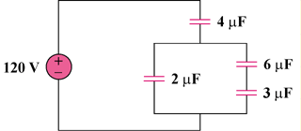
C₁
C₂
C₃
C₄

Figure 6.57
For Prob. 6.23.

